Name: Ho Ping Chong

Student no: 1155057016

GNBF5010-Assigment 4

**Question:**

Write a python program to print Fibonacci sequence. The length of output sequence is specified by the first command line parameter in python package

**Answer:**

Firstly we write the python code on by different algorithms for Fibonacci sequence creation and separate in different function as in Fib.py

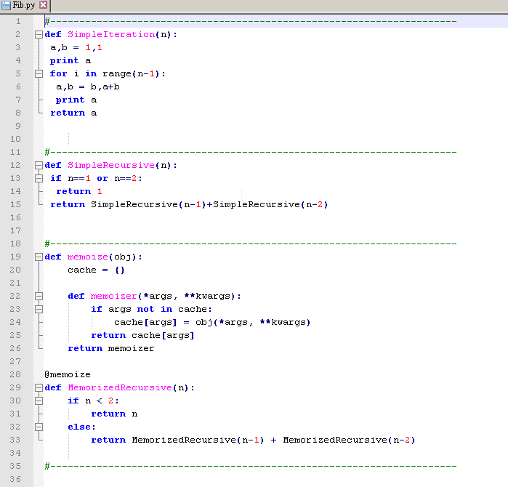

Then we prepare the file for python package which include __init__.py and setup.py files

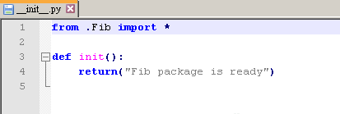

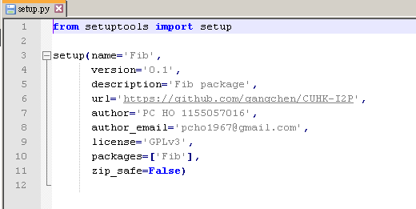

In command prompt, we change director to the Fib folder and run setuptools to create the python package or the python egg.

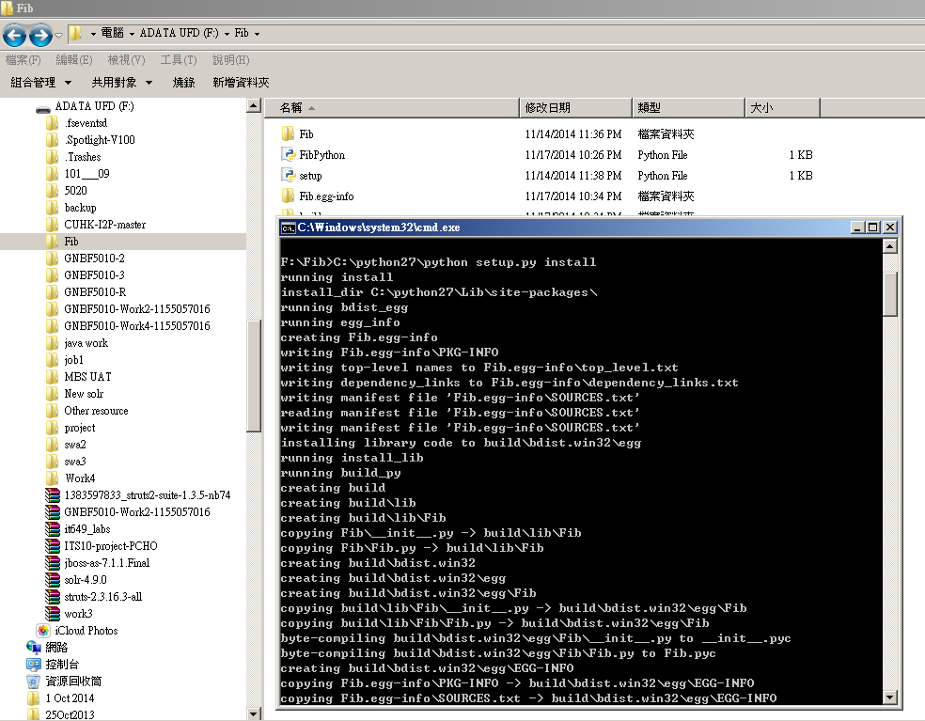

It will create python egg with additional files such as dist, build, Fib.egg-info folder where dist folder contain the python package of Fib in a file name as Fib-0.1-py2.7.egg.

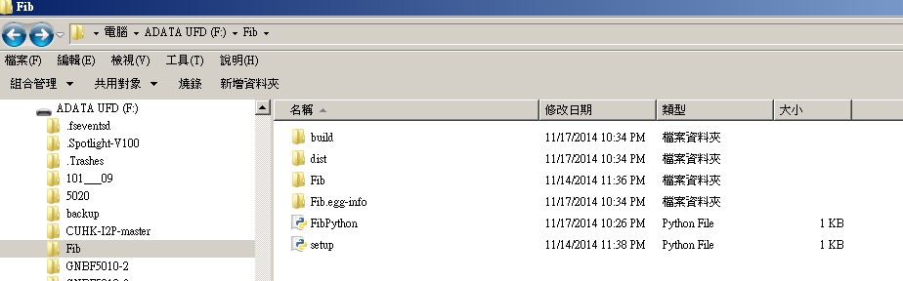

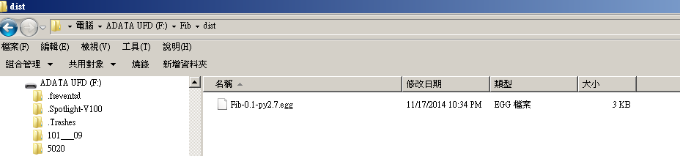

The file use our package name as prefix then version number declare in the setup.py, python version to generate the python byte code with a file name extension as .egg. It is the python package which ready for distribute and install on any PC by easy setup or PIP.

We download easy_install from web then use it to install Fib-0.1-py2.7.egg into python site-packages folder.

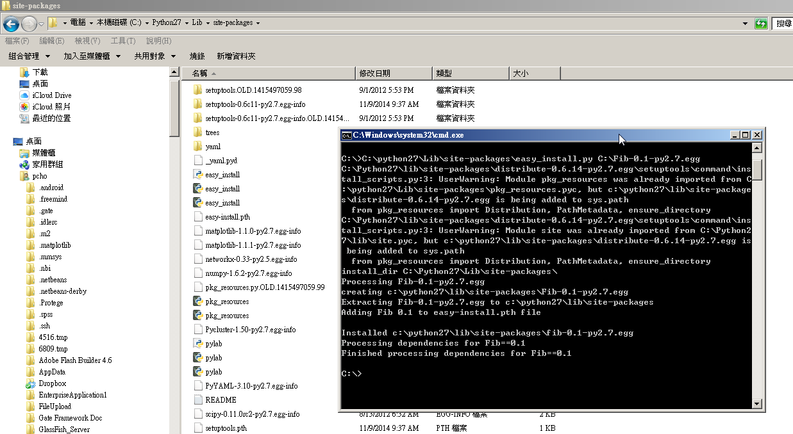

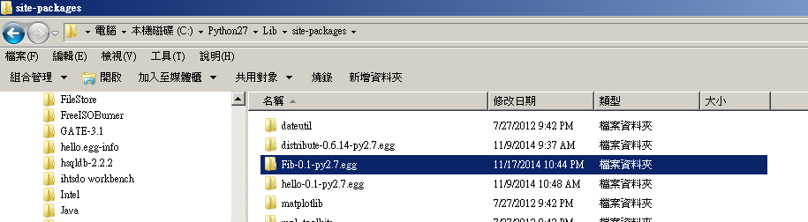

We create FibPython.py to import Fib package and pass parameter through argument

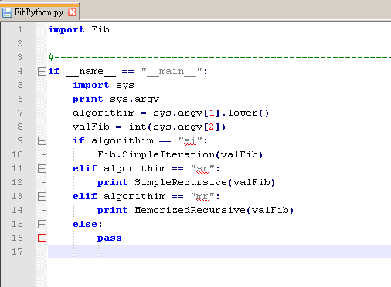

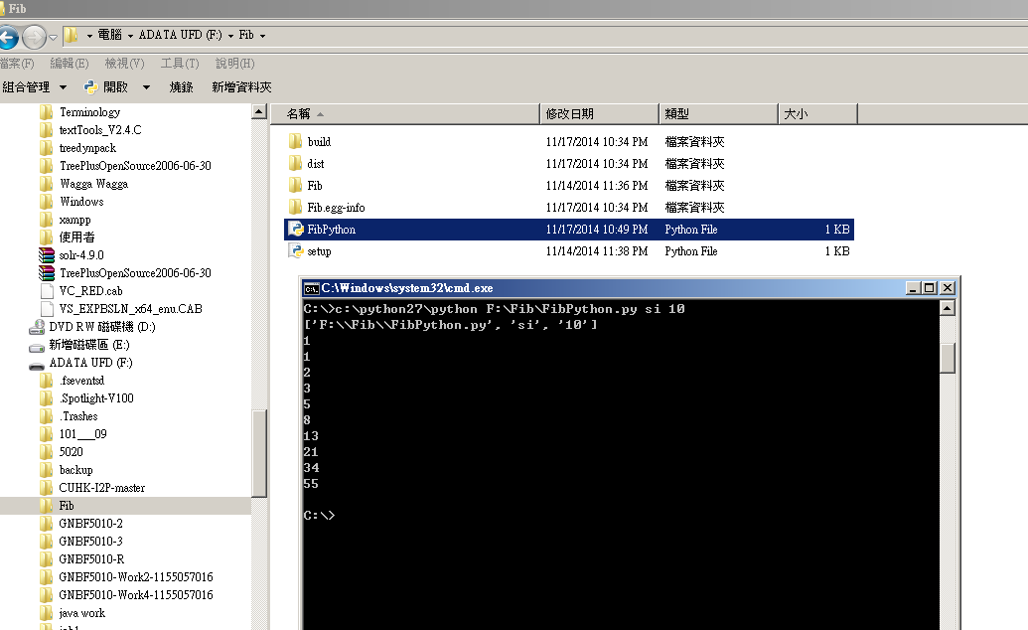

The demo show the step to prepare a package or egg of a python code then distribute and install in python and use as import object for other user and code reuse.

I am submitting the assignment for:

x□ an individual project or

□ a group project on behalf of all members of the group. It is hereby confirmed that the submission is authorized by all members of the group, and all members of the group are required to sign this declaration.

I/We declare that the assignment here submitted is original except for source material explicitly acknowledged, the piece of work, or a part of the piece of work has not been submitted for more than one purpose (i.e. to satisfy the requirements in two different courses) without declaration, and that the submitted soft copy with details listed in the <Submission Details> is identical to the hard copy(ies), if any, which has(have) been / is(are) going to be submitted. I/We also acknowledge that I am/we are aware of University policy and regulations on honesty in academic work, and of the disciplinary guidelines and procedures applicable to breaches of such policy and regulations, as contained in the University website [http://www.cuhk.edu.hk/policy/academichonesty/](http://www.cuhk.edu.hk/policy/academichonesty). In the case of a group project, we are aware that each student is responsible and liable to disciplinary actions should there be any plagiarized contents in the group project, irrespective of whether he/she has signed the declaration and whether he/she has contributed directly or indirectly to the plagiarized contents.

It is also understood that assignments without a properly signed declaration by the student concerned and in the case of a group project, by all members of the group concerned, will not be graded by the teacher(s).

____Ho Ping Chong__ ____21 Nov 2014______

Signature(s) Date

Ho Ping Chong___ ___1155057016_____

Name(s) Student ID(s)

____GNBF5010_______ __Introduction to programming___

Course code Course title